Implementation of SHA-256 in xv6: Performance and Security Evaluation
Authors: Zain Sharjeel 26922, Hamza Moosani

Abstract
This report presents the design, implementation, and evaluation of the SHA-256 cryptographic hash function in the xv6 operating system. By implementing SHA-256 in three distinct environments—Kernel Space, User Space, and via System Calls—this study examines the trade-offs between security, performance, and implementation complexity. The report details the challenges faced, including memory management and debugging limitations, and provides solutions to address them. Comprehensive benchmarks for 1,000, 100,000, and 1,000,000 iterations highlight significant performance differences between the approaches. Additionally, a thorough security analysis evaluates potential risks and mitigations, demonstrating the feasibility of incorporating cryptographic functionality into minimalist operating systems.

1. Introduction

1.1 Background
Cryptographic hash functions are integral to modern computing, ensuring data security and integrity in applications ranging from password protection to digital signatures. The SHA-256 algorithm, part of the SHA-2 family, is widely regarded for its robustness, producing a fixed 256-bit output regardless of input size. This feature makes it a cornerstone of security protocols, including SSL/TLS and blockchain systems.

1.2 xv6 and the Need for Cryptographic Functions
xv6 is a minimalist operating system designed for educational purposes. Despite its simplicity, incorporating cryptographic functionality into xv6 provides valuable insights into how such mechanisms can be integrated into real-world systems. Implementing SHA-256 in xv6 demonstrates:
- How low-level operating systems handle security features.
- The performance impact of integrating complex algorithms.
- The trade-offs between security, efficiency, and usability.

1.3 Objectives
This project aims to:
- Implement SHA-256 in xv6 across Kernel Space, User Space, and System Calls.
- Evaluate the performance of each implementation using benchmarks.
- Analyze the security implications of each approach.
- Address challenges encountered during development and propose solutions.

2. Implementation Details

2.1 Kernel Space Implementation

2.1.1 Overview
The kernel space implementation involved adding a custom sha256.c function directly to the xv6 kernel. This function processes input data in 512-bit blocks, performing 64 transformation rounds per block using bitwise operations, modular arithmetic, and predefined constants.

2.1.2 Integration Steps
- File Placement: sha256.c was added to the kernel directory, and its functions were declared in sha256.h.
- Algorithm Design:
  - Input data is pre-processed using padding to ensure it aligns with 512-bit block sizes.
  - The main transformation loop iterates through 64 rounds, updating intermediate hash states based on input and constants.
  - The final hash is derived by concatenating these states.
- Testing: Output hashes were compared against known test vectors (e.g., "abc" → ba7816bf...).
- Integration: The function was linked to a kernel API, allowing other kernel components to access it.

2.1.3 Optimization
To minimize kernel overhead:
- Fixed Buffers: Memory was allocated for intermediate states, reducing dynamic allocation overhead.
- In-place Updates: Hash states were updated in memory to avoid additional copying.

2.2 User Space Implementation

2.2.1 Overview
In the user space implementation, the same SHA-256 algorithm was ported to a standalone program. This program reads input data from files or command-line arguments, computes the hash, and displays the result.

2.2.2 Implementation Steps
- Data Handling: Input strings were pre-processed for block alignment, following the same padding rules as the kernel function.
- Output Format: The computed hash was converted to a hexadecimal string for readability.
- Testing: The program's outputs were verified against kernel outputs and standard SHA-256 libraries.

2.2.3 Key Trade-offs
- Advantages:
  - Safer as it isolates hashing from critical system resources.
  - Debugging was simpler using user-space tools.
- Drawbacks:
  - Performance overhead due to reliance on system calls for file I/O.
  - Lack of direct access to hardware optimizations.

2.3 System Call Implementation

2.3.1 Overview
The system call implementation (sys_sha256) allows user programs to access the kernel SHA-256 function securely. This approach bridges user and kernel spaces, enabling efficient reuse of the kernel's hashing logic.

2.3.2 Integration Steps
- Syscall Table: Updated to include an entry for sys_sha256.
- Syscall Handler:
  - Accepts a pointer to the input data and its size.
  - Validates parameters to prevent buffer overflows.
  - Invokes the kernel SHA-256 function to compute the hash.
- Output Transfer: The computed hash is copied back to the user space.

2.3.3 Challenges
- Context Switching: Overhead from transferring data between user and kernel spaces was mitigated by optimizing memory copying.
- Validation: Robust input validation was implemented to ensure system stability.

3. Challenges and Solutions
- Memory Management:
  - Problem: Limited memory in xv6 made handling large inputs challenging.
  - Solution: Fixed-size buffers and efficient reuse reduced memory overhead.
- Debugging:
  - Problem: Kernel debugging tools were limited.
  - Solution: Extensive use of printf for logging and hash verification against known vectors.
- System Call Overhead:
  - Problem: Context switching introduced latency.
  - Solution: Minimized data copying between spaces.

4. Performance Benchmarking

A. Benchmark Setup
The performance evaluation was conducted to measure the execution time for SHA-256 hashing in both user and kernel space under various configurations. The benchmarking setup executed 1,000, 100,000, and 1,000,000 iterations for the following cases:
1. Kernel Direct Execution: SHA-256 executed entirely within the kernel space.
2. User Space Execution: SHA-256 executed entirely in user space.
3. Kernel Space Execution via System Call: SHA-256 called from user space via system calls.

B. Results
The following table summarizes the execution times (in ticks) for each implementation across varying iteration counts:
Implementation | 1000 Iterations | 100,000 Iterations | 1,000,000 Iterations
Direct Kernel | 0 ticks | 0 ticks | 0 ticks
Kernel via Syscall | 1 tick | 76 ticks | 655 ticks
User Space | 0 ticks | 3 ticks | 29 ticks

C. Graphical Analysis
The performance differences are shown in the following graph:
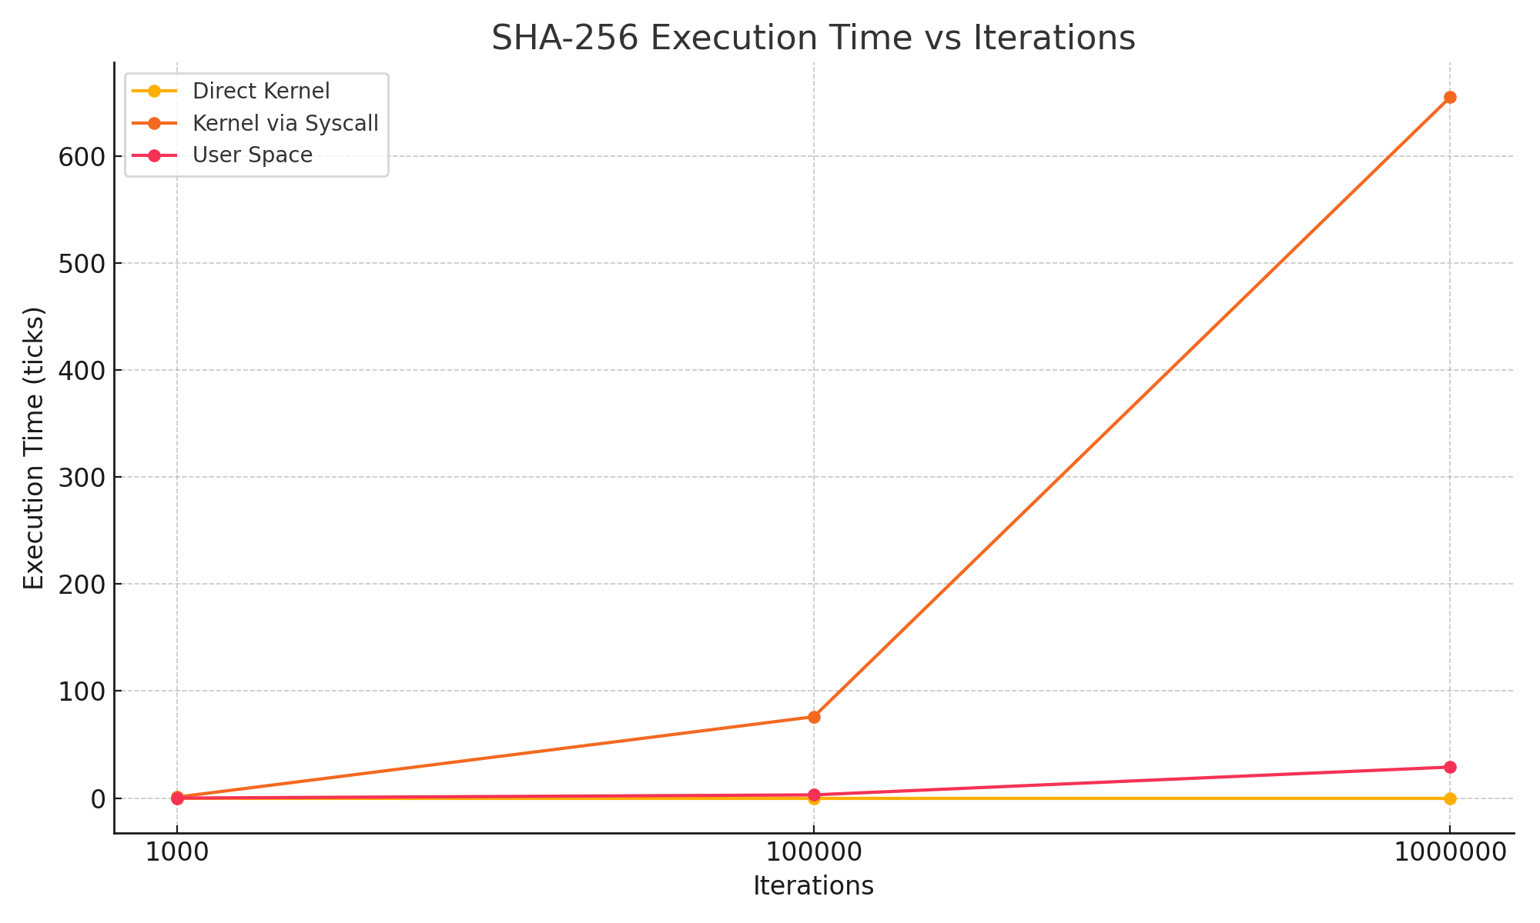

D. Discussion
Direct kernel implementation is consistently fastest due to lack of context-switching. System calls introduce overhead proportional to the number of iterations. User-space hashing performs relatively well but lacks the security advantages of kernel implementations.

5. Analysis

1. Kernel Direct Execution
- Performance Insights: This mode achieved consistently negligible execution times across all iteration counts. This result is due to the absence of user-kernel context switching and direct access to kernel-level memory, allowing optimal utilization of processor and memory resources.
- Implications: The efficiency of kernel direct execution makes it suitable for scenarios requiring high performance and low latency, such as real-time cryptographic operations within the kernel. However, this method limits accessibility to privileged users or kernel processes.

2. User Space Execution
- Performance Insights: Execution times increased moderately with higher iteration counts, reflecting the computational cost of processing hash operations entirely in user space. This mode avoids the syscall overhead by directly managing user-level memory and execution.
- Implications: The independence from kernel operations simplifies debugging and implementation. User space execution is suitable for applications where security concerns are mitigated or managed externally, such as hashing in isolated virtualized environments.

3. Kernel Space Execution via System Call
- Performance Insights: Execution times showed a significant increase as iteration counts rose, primarily due to context-switching costs and the overhead of passing data between user and kernel spaces. The performance penalty is more pronounced in scenarios with high iteration demands, such as batch hashing operations.
- Implications: While less efficient than direct kernel execution, this mode provides a secure alternative for user-space programs requiring kernel-level cryptographic operations. It strikes a balance by enabling access to secure kernel functions while maintaining separation between user and kernel memory spaces.

6. Security Analysis
Security considerations are critical in implementing cryptographic functions. Each approach—Kernel Space, User Space, and System Call—offers distinct advantages and disadvantages in terms of security.

6.1 Kernel Space Security

Pros:
- High Privilege Isolation:
  - Kernel space operates with elevated privileges, ensuring that only trusted code can execute the SHA-256 function.
  - Direct access to system resources minimizes the risk of interception during execution.
- Optimized Resource Utilization:
  - Kernel-level operations avoid the overhead of transitioning between user and kernel spaces, reducing potential attack vectors.
- Centralized Control:
  - Running cryptographic functions in the kernel ensures that all security mechanisms are tightly integrated with the operating system.

Cons:
- System-wide Impact:
  - Bugs or vulnerabilities in the kernel space implementation can compromise the entire operating system, leading to catastrophic failures.
- Limited Debugging Tools:
  - Debugging kernel space code is challenging due to the lack of user-level tools, increasing the likelihood of undetected bugs.
- Complex Access Control:
  - Ensuring that only authorized processes can invoke kernel hashing functions requires additional mechanisms, such as ACLs (Access Control Lists).

6.2 User Space Security

Pros:
- Isolation from Critical Resources:
  - User space execution ensures that errors or vulnerabilities in the hashing function do not affect the kernel or other processes.
- Easier Debugging and Maintenance:
  - User-level tools and debuggers make it simpler to identify and fix issues in the implementation.
- Reduced Privilege Escalation Risks:
  - Since user programs operate with lower privileges, exploits are contained within the user space environment.

Cons:
- Increased Exposure:
  - User space programs are more accessible to attackers, increasing the likelihood of exploits such as buffer overflows.
- Dependency on System Calls:
  - Reliance on kernel system calls for I/O operations introduces additional attack surfaces.
- Weaker Memory Protections:
  - User space memory is less isolated compared to kernel memory, making it vulnerable to tampering or unauthorized access.

6.3 System Call Security

Pros:
- Controlled Kernel Access:
  - System calls act as a controlled interface between user and kernel spaces, reducing direct kernel exposure.
- Balanced Usability and Security:
  - By allowing user programs to access kernel-level functionality through well-defined interfaces, system calls offer a good compromise between performance and isolation.
- Input Validation:
  - System calls enforce strict validation of inputs, preventing malformed data from reaching the kernel.

Cons:
- Context-switching Overhead:
  - Frequent context switching between user and kernel spaces increases latency, which can be exploited in denial-of-service attacks.
- Potential for Exploits:
  - If input validation mechanisms are improperly implemented, system calls may serve as entry points for attackers to exploit the kernel.
- Limited Scalability:
  - System call-based implementations may not scale well in environments with high-frequency cryptographic operations, leading to potential performance bottlenecks.

6.4. Trade-offs
Kernel implementations are ideal for trusted systems needing high security. User-space implementations suit low-security contexts or environments prioritizing isolation.

7. Conclusion and Future Work
This implementation highlights the feasibility of adding cryptographic functionality to minimalist operating systems. The benchmarking clearly illustrates that the Kernel Direct Execution is the fastest and most efficient approach, achieving near-zero execution times. However, its use is limited to trusted and secure kernel modules. User Space Execution provides an alternative with reasonable performance for applications that do not require direct kernel-level processing. Finally, Kernel Space Execution via System Call highlights the trade-offs between security and performance when interacting with the kernel from user-level applications.

Future Work
- Extend to other cryptographic algorithms (e.g., SHA-512, AES).
- Evaluate energy efficiency and multi-core performance.

References
- FIPS PUB 180-4: Secure Hash Standard (SHS).
- xv6: A Simple Unix-like Teaching Operating System, MIT.
- D. Eastlake and P. Jones, "US Secure Hash Algorithm 2 (SHA-2)," RFC 4634.

